Consulting Report for Rachel Stec
Prepared by Drew Olson

The executive summary
This study looked at comparing a few different things. They wanted to see to if there was a difference between the scores on the Urinary Catheter Management pre/post. They also wanted to see if there was a difference in the incidence rate of CAUTIs between the pre and the post. Overall, there was a difference in the scores on the Urinary Catheter Management between the pre and the post, there was not a significant difference in the incidence rate pre/post.

Research questions

- Was there a difference in scores on the Urinary Catheter Management pre/post?
- Was there a difference between the observed and expected rates for the incident rate of CAUTIs?
  - Ho: No difference in Incidence Rate between pre/post
  - Ha: There is a difference in Incidence Rate between pre/post
- Did the intervention help create higher scores post intervention.

Data
The data was grouped into two groups: pre and post. The pre group consisted of the months January through June. The post group consisted of August and September. July was removed since this was the time the intervention took place.

Methods

To answer the first question, I took a paired t-test on Urinary Catheter Management scores. To answer the second question, I had to group the data into the pre and the post months. The pre intervention was January-June and the post was August and September. I removed July from the data since this was the month the intervention took place. I calculated the expected rate of CAUTI incidents based on the number of Resident Days. I also calculated the observed rate. A chi squared test was conducted to determine if there was a significant difference between the expected result and the observed result.

To answer question three, I took the means of each survey question and plotted them on a scatterplot. Points are lined up with their respective question. Since the answers were all very similar, I had to use displacement which slightly shifted all the points either left or right. All the means should be between the Agree and Strongly Agree.

Results

Overall, there was a difference in the Urinary Catheter Management Scores between the pre and post intervention. However, when comparing the expected rate of CAUTI rate infections to what was observed there was not significant enough evidence to say that there was a change between them.

Table one is a t test used to determine if there was a significant difference in the Urinary Catheter Management scores between the pre and post. The means for the pre and post were included as well. The p-value was <.0001 which means that there was a significant change in the scores pre post.

Table two is broken down into three pieces. You’ve got the total number of CAUTI occurrences and Total Residency Days for pre post in the first category. You’ve got the comparison of the expected and observed CAUTI rates pre post in the second section. In the third section you’ve got the chi squared test that tests to see if there is a significant difference between the observed and expected rates. The X squared is zero which means that we do not reject the null hypothesis (Ho). The p-value is one which does not hit our criteria of <.05 which means that there is not enough evidence to say that there a difference between them.

Table three shows the means score for each question on the post survey. All the scores are within that 6-7 range, or the Agree to Strongly Agree range.
Figure one is a scatterplot representing the mean score for each question on the Post Survey. Slight adjustments were made to the points because they are all close together.

Table 1: T-test to determine whether there was a difference pre/post for the Urinary Catheter Management scores
Mean(Pre) | Mean(Post) | p-value
7.2 | 9.0 | <.0001
*Significance level at 0.05

Table 2: Chi Squared test to determine a difference between Observed and Expected rate

 | Pre | Post | X-squared | p-value
Total CAUTI | 11 | 8 | 0 | 1
Total Residence Days | 18800 | 6929 | 0 | 1
Expected Rate | 88.04 | 11.96 | 0 | 1
Observed Rate | 73.07 | 26.93 | 0 | 1
*Significance level at 0.05

Table 3: Mean Scores for Post Survey Questions
Questions | Mean
Consider Other Options | 6.55
Sense of Direction | 6.55
Consider Root Cause | 6.60
Consider Evidence | 6.55
Consdier Catheter Removal | 6.25
Initiating Discontinuation | 6.5
Increased Confidence | 6.65

Figure 1: Scatterplot of Post Survey Means
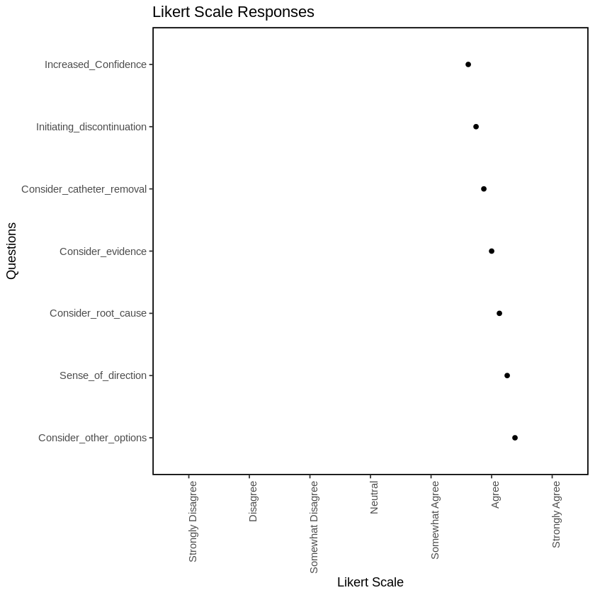

Appendix
All Data Analysis was done in R Colab. A link to the Colab file is below.

https://colab.research.google.com/drive/1LkC-QYWqw6w8-lpn-0hwkcc_tO6-aUMP?usp=sharing

